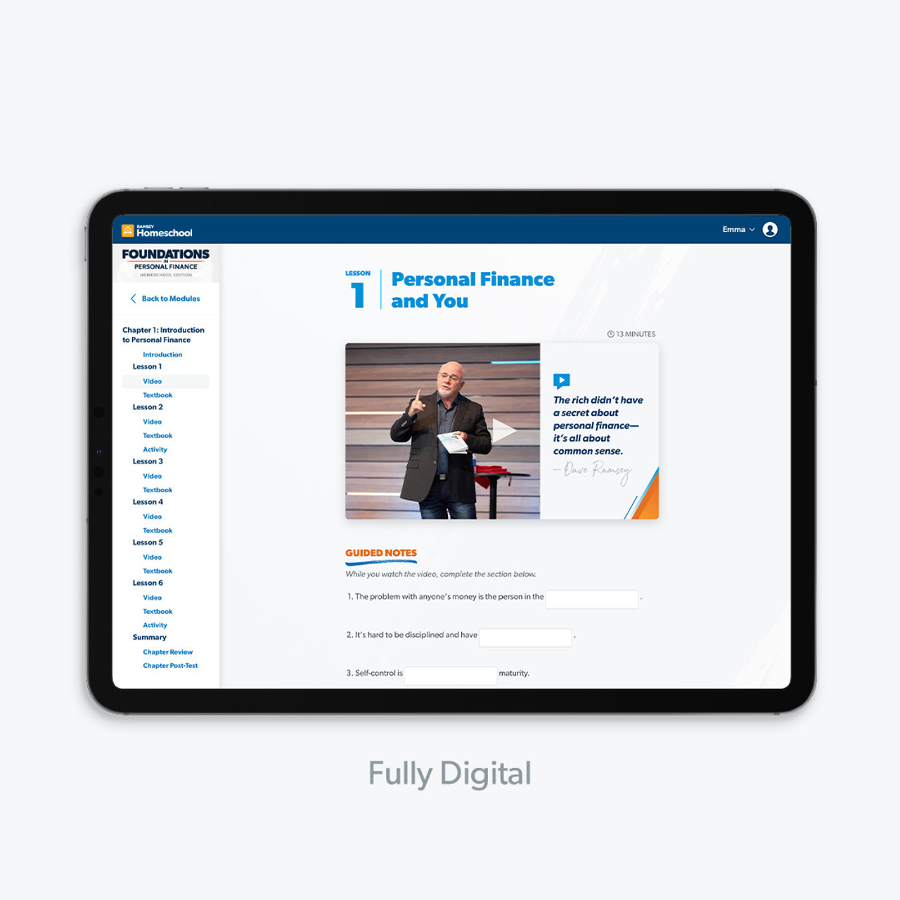

Our teens will learn the money skills they’ll use now and for the rest of their lives so they’ll have a solid foundation when they’re out on their own (see where we got the name?) But it doesn’t just stop there. This course trades boring formulas and financial theories for time-tested principles, real-life applications and humor (yes, personal finance can be fun!).

And, there’s no personal finance degree required! Dave Ramsey and our team of experts teach all the content for you—so you don’t have to sweat it. You’ll get everything you need, from lesson guides to engaging video lessons to auto-graded assessments—so you can teach confidently.

This product is available on Ramsey Homeschool and includes a fully digital textbook as well as streaming video lessons.

**Curriculum Features:**

* Parent-led or independent study learning options
* Teacher resources (lesson guides, activities, transcripts and more!)
* 13 stand-alone chapters that can be taught in any order
* Devotionals and a scripture reference guide for additional study on the biblical view of finances
* Easy, secure course access