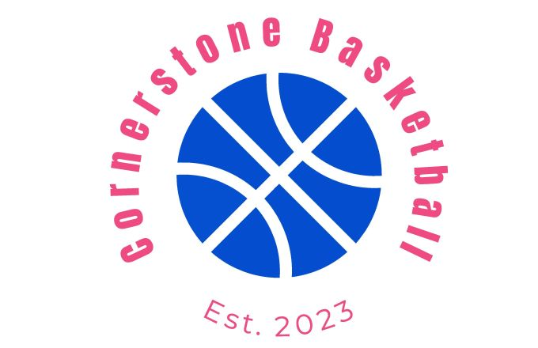

Basketball Skills Training at Cornerstone Basketball
At Cornerstone Basketball, we are dedicated to helping players of all skill levels grow in their understanding and mastery of the game. Our program focuses on building a strong foundation through fundamental skills while also challenging players to develop advanced techniques.
Core Skills We Focus On:
- Ball Handling:
  - Develop confidence and control with both hands.
  - Master dribbling techniques, including crossover, behind-the-back, spin moves, and more.
- Shooting Mechanics:
  - Improve shot form, accuracy, and range.
  - Focus on proper footwork, release timing, and consistency.
- Passing & Court Vision:
  - Learn precision passing techniques such as bounce, chest, and overhead passes.
  - Enhance decision-making to anticipate plays and create opportunities for teammates.
- Defense:
  - Teach individual and team defensive principles, including positioning, footwork, and reading the offense.
  - Emphasize hustle and intensity to disrupt opponents.
- Rebounding:
  - Focus on timing, positioning, and effort to secure the ball.
  - Teach offensive and defensive rebounding techniques.
- Footwork & Agility:
  - Work on balance, coordination, and explosive movement.
  - Improve pivoting, cutting, and overall quickness on the court.
- Game IQ:
  - Build an understanding of offensive and defensive strategies.
  - Teach situational awareness and how to adapt during games.
Specialized Training:
- Position-Specific Skills: Tailored drills for guards, forwards, and centers.
- Game Simulation: Live scrimmages to apply skills in real-game scenarios.
Our experienced coaches create an encouraging, disciplined, and fun environment where players are inspired to push themselves while fostering teamwork and leadership. Whether you’re a beginner eager to learn or an advanced player preparing for competitive play, Cornerstone Basketball is here to help you reach your full potential.

